Final Project:

***Optical Character Recognition System***

Aayushi Gupta, Mila Hristova

College of Professional Studies

Northeastern University

EAI6020: AI System Technologies

CRN: 80858

Dr. Daya Rudhramoorthi

July 03, 2021

**INTRODUCTION**

Cemeteries serve a vital function in the community. They must be specifically planned for and maintained as a place of remembrance and sadness. Hand-drawn maps of the cemetery’s boundaries, sections, subdivisions, lots, and grave places were previously created and usually paper records were retained. The associated attribute data was usually kept in paper books or spreadsheets and updated manually. This method is very time-consuming, inefficient, and cost-ineffective approach of cemetery mapping and record keeping. It is also difficult to update and manage the records because the hard-copy property maps and attribute data are not connected. Paper maps and files are also difficult to keep and transport while they are quickly misplaced, ripped or stolen.

Paper products deteriorate over time and are vulnerable to fire and water damage. Markings made with a pencil fade with time and are readily smeared. Furthermore, the actual information contained inside these documents varies, and due to a lack of consistency, critical information may be missed.

Both cemetery employees and visitors benefit from cemetery software since it allows them to manage data and find gravesites more quickly and efficiently. The cemetery can save time and money by implementing these 21st century practices.

Moving to a digital cemetery management system is important to accurately prepare and cleanse burial records from scanned paper-based records to a useful digital format, which can subsequently be consumed/migrated to a Cemetery Management System to obtain value. With the help of a cemetery information management system, one can back-up all the records and control who has access to the data.

**PROJECT DESCRIPTION**

The aim of the project is to extract data from various scanned paper-based burial records and store it in a digital format for easy access and usage. The burial records presented were stored in different formats. For convenience, we categorized the records into two types- Type A and Type B Burial Records. Initially we had created three categories as A, B and C but as B and C were similar in the kind of information they had, we grouped them under one category.

We read the records and extracted the data using region of interests and then stored them in the database. The data was properly cleaned, and we created a dashboard using Power BI to display the data and get insights. With the help of the dashboard, we were able to visualize the different age range death rates and determine which age group has higher percentage of death rate within Type A and Type B records. The analysis that was ran show that Type A has burial records of 14 deaths within the age of 75+ and only 1 death in Type B. The overall collection of data shows 51.19% death rate and Type B has 48.81% based on the number of images that each type had available.

**LANGUAGE USED**

We have used Python programming language in our project and have worked on the Visual Studio Code IDE. Python is a high-level, general-purpose and a very popular programming language. Python programming language is being used in web development, Machine Learning applications, along with all cutting-edge technology in Software Industry. Python has various benefits-

1. Easy to learn and use
2. Python is an interpreted language which means that Python directlyexecutes the code line by line.
3. Free and open source
4. Dynamically typed

**PACKAGES USED**

Our project requires the installation of these two packages-

1. OpenCV: To install OpenCV run the following command in the terminal/command prompt-

pip install opencv-python

1. Cloud Vision API: This is the third-party library we used to read the data from images. To use the API, an account needs to be created and then its services can be used. To create an account and get the API key, follow the steps given below-:

Visit <https://cloud.google.com/vision/> . Google services provide two different API versions: AutoML API and Vision API. The one that our team has used is Vision API.

First, we ‘Get started’ with Vision API to access the version that is needed for our project.

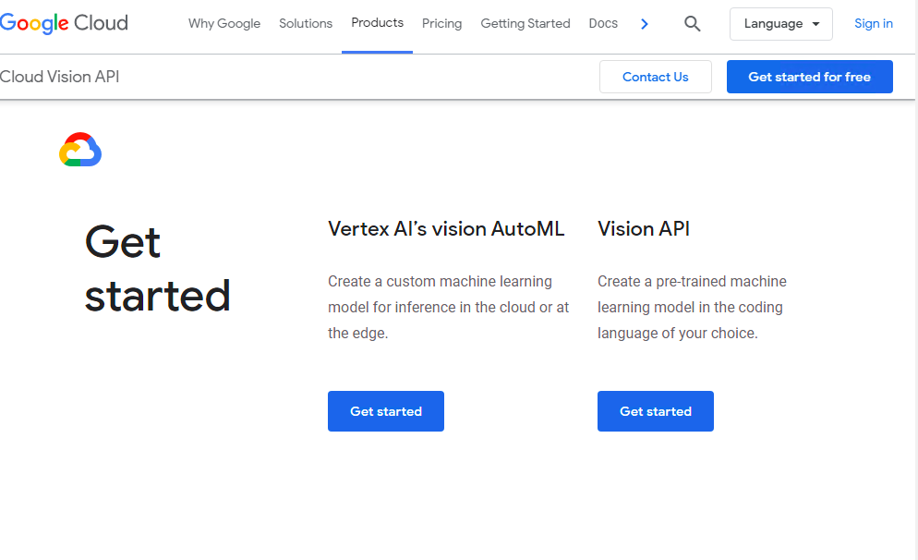

This brings us to ‘Using API Explorer’ page through which we navigate further.

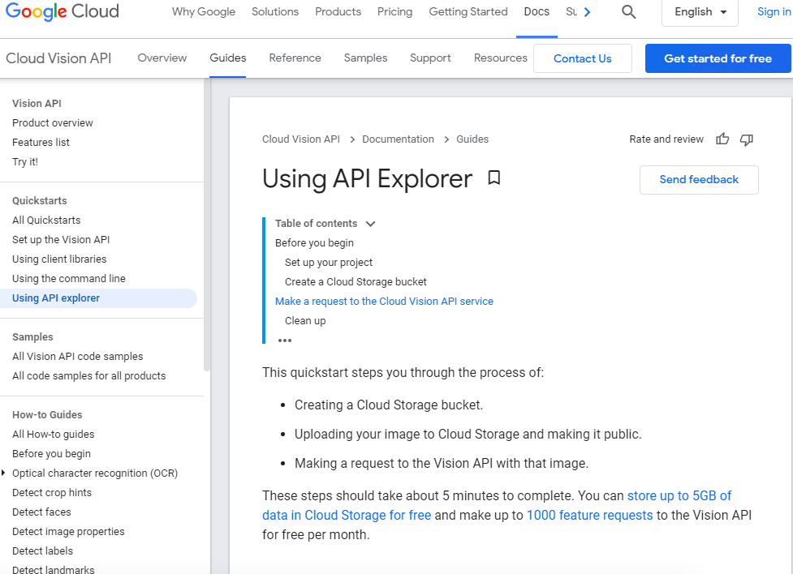

Next step requires to open a new tab and access Google Cloud Platform which asks for an identification.

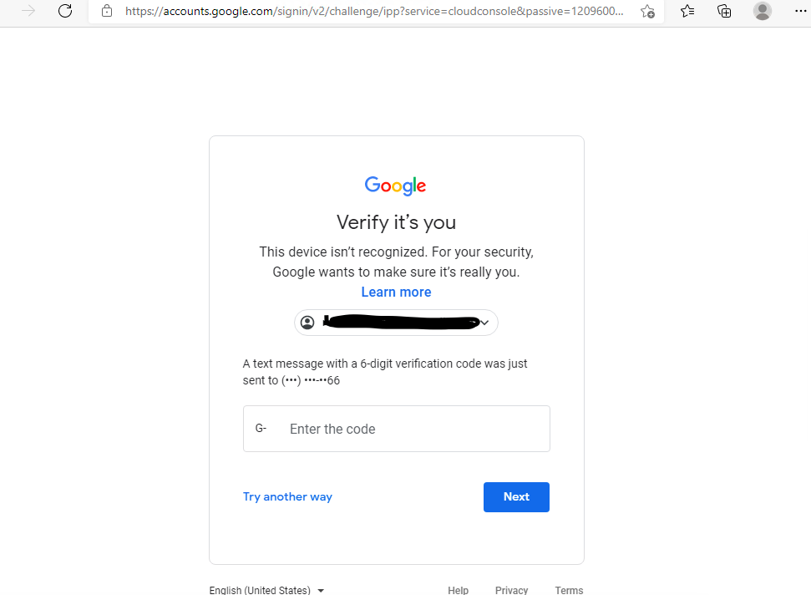

Once verified, next is to access the API Library.

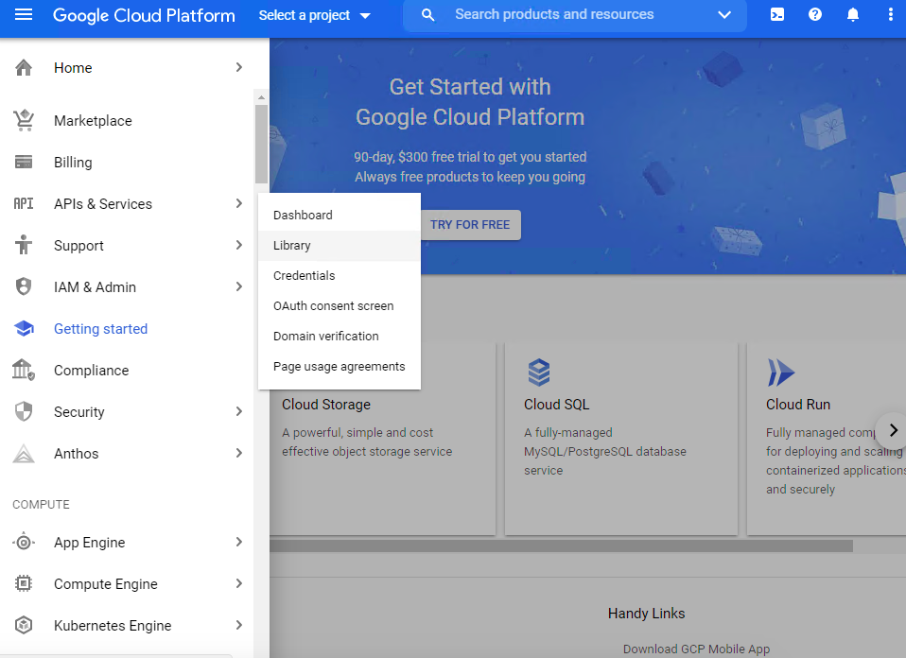

Next step is to search Vision API and enable the tool.

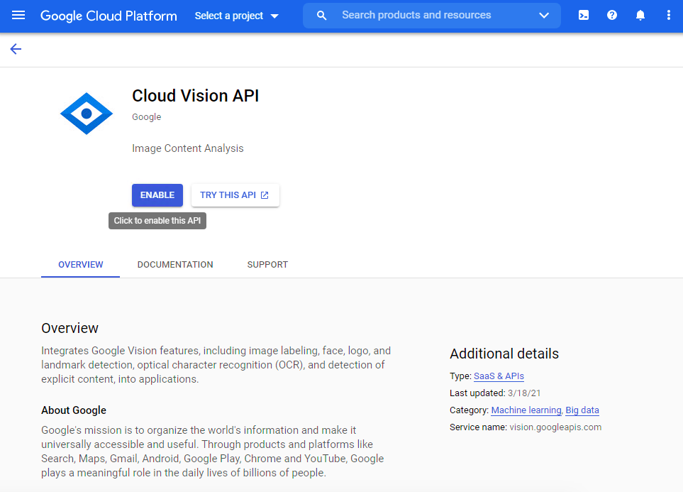

Once enabled, we need to access new project tab.

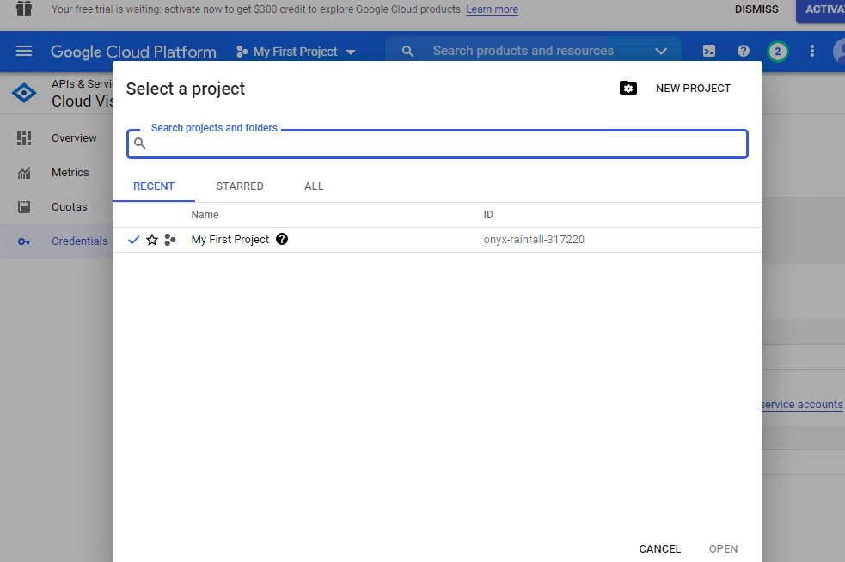

Next step is to create new credentials.

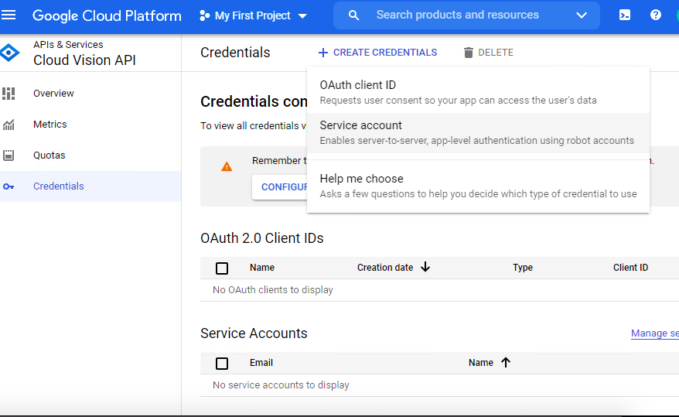

This step is particularly important. It allows you to create a key and download as a JSON file which further on is used in a terminal to connect API with the system that will be used to read the images imported.

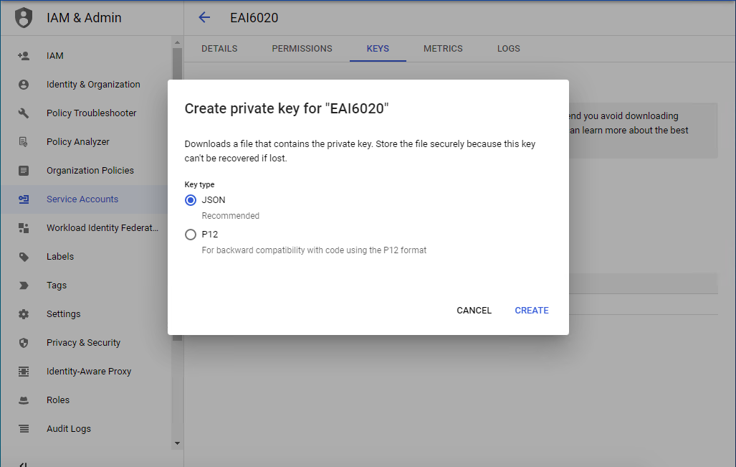

Once the key is downloaded, open the command prompt and run the following commands in command prompt-  
python venv

python -m venv VisionAPI

Put the JSON file in the recently created folder- VisionAPI and run the below commands in the command prompt-

cd VisionAPI

scripts\activate

pip install google-cloud-vision

You can then use the command pip list to see the packages installed.

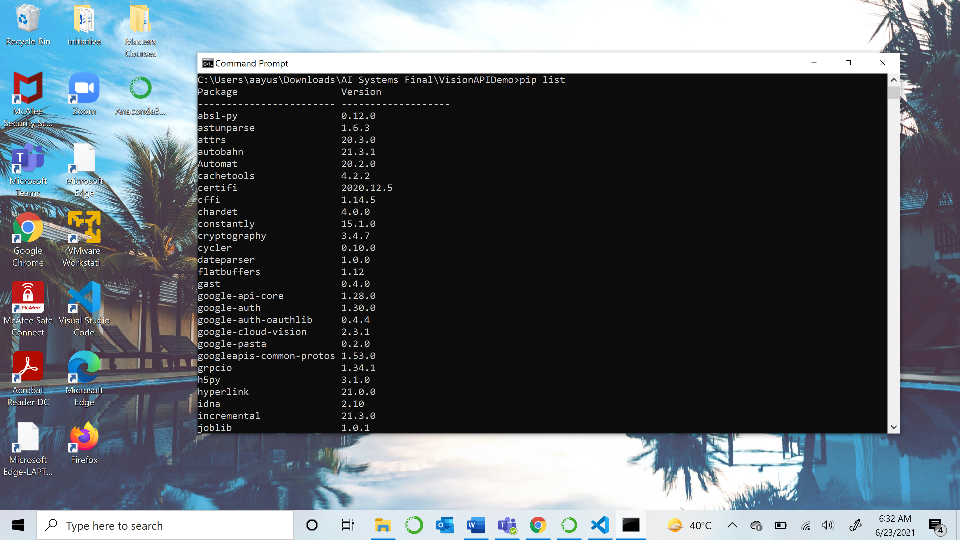

**DATABASE USED**

We stored our extracted data in CSV files. A Comma Separated Values (CSV) file is a plain text file that contains a list of data. A CSV file has a simple structure. It is a list of data separated by commas. For convenience, we created two CSV files to store our Type A and Type B data.

**METHODOLOGY**

1. Importing the necessary modules:

We first import all the libraries that are going to be used in our project.

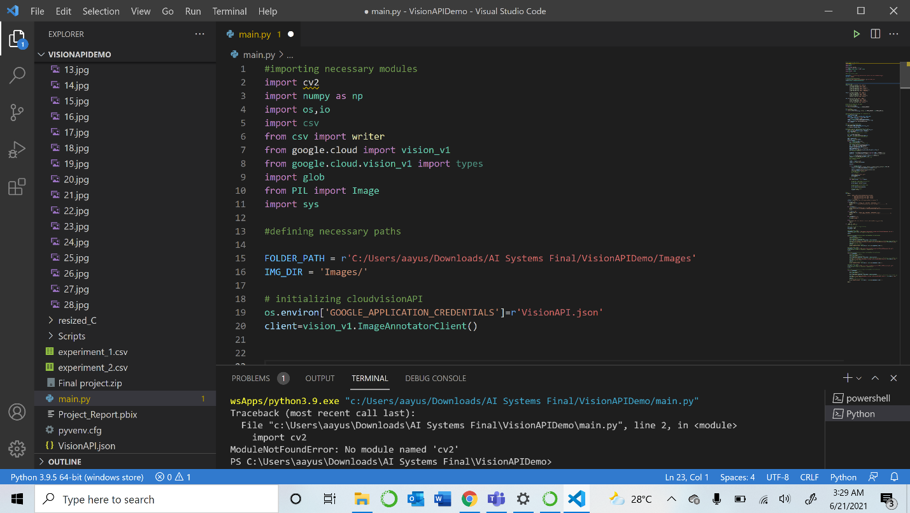

1. Initializing the Cloud Vision API: To be able to read the data using this API, we need to initialize our Cloud Vision API.



1. Main function:

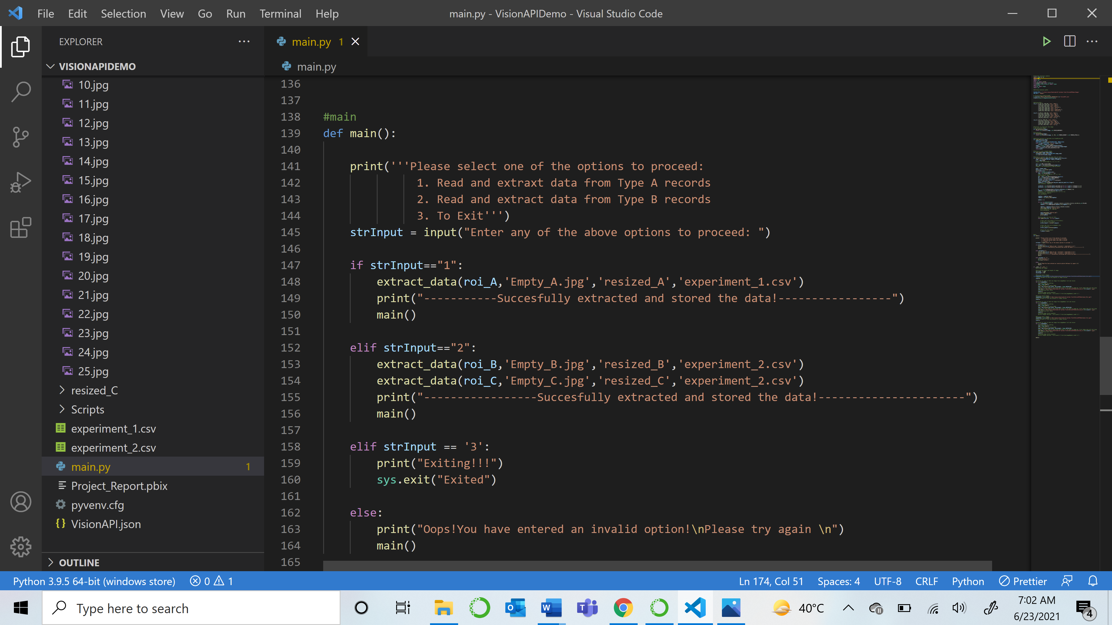

The main function takes the input of the user and then performs all the operations on the images depending on his input as Type A or Type B.

1. Preprocessing the images:

To be able to read data accurately, there is some preprocessing that needs to be done which includes resizing the images to a standard size, gray-scaling, and thresholding.

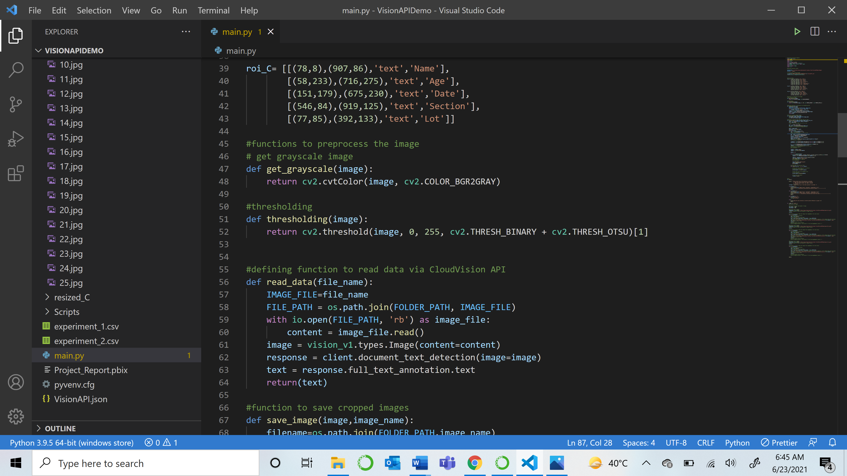

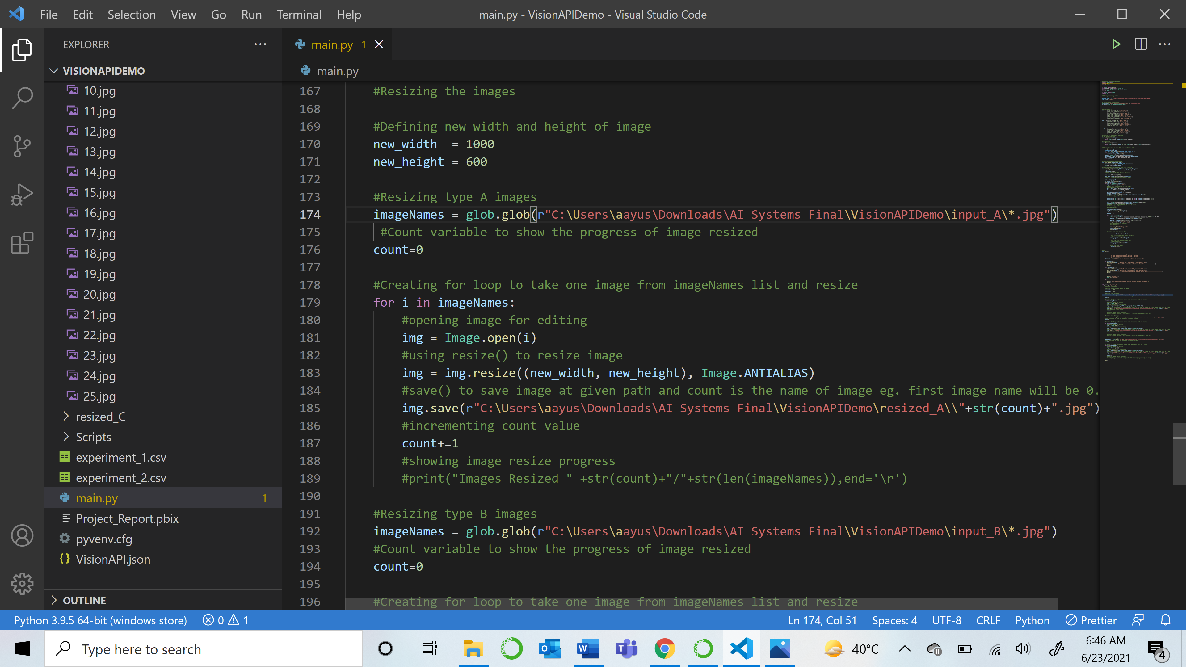

1. Data Extraction:

To extract the data, we first created empty templates of our forms as shown below-

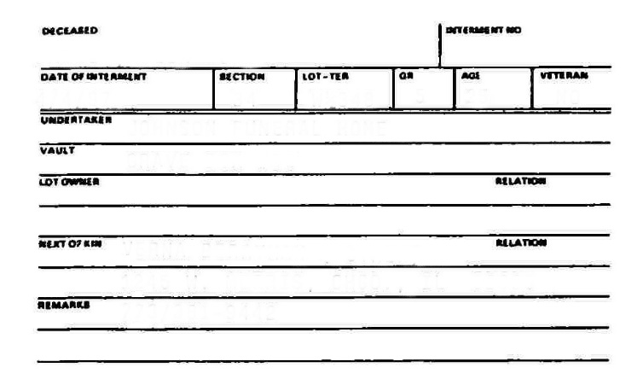

This template was used to detect the keypoints orb.detectAndCompute as below-

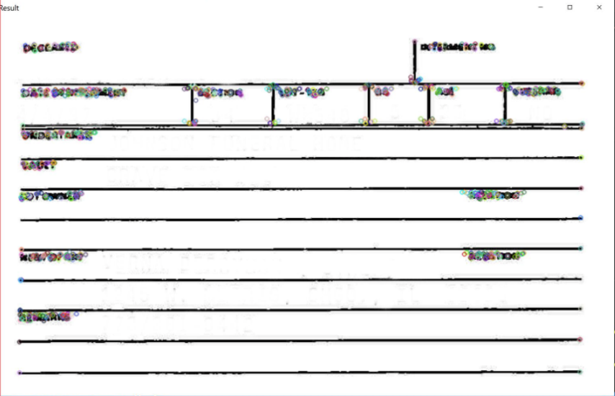

After the keypoints were detected, we used BruteForce Matcher to match the keypoints in our input image-

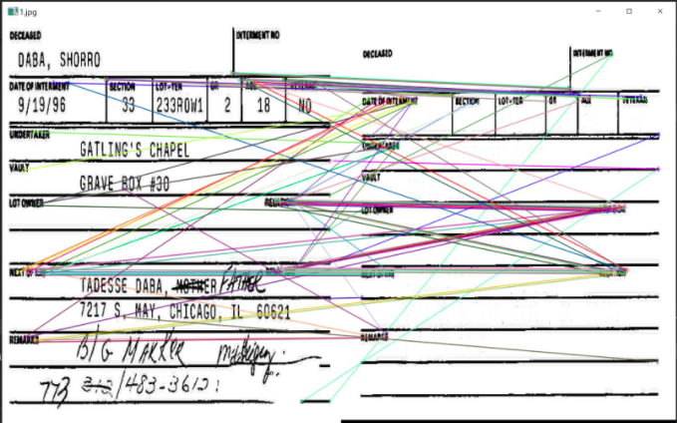

To extract the data and store it under the correct column names, we defined certain region of interests which was used to detect the area of text in the image-

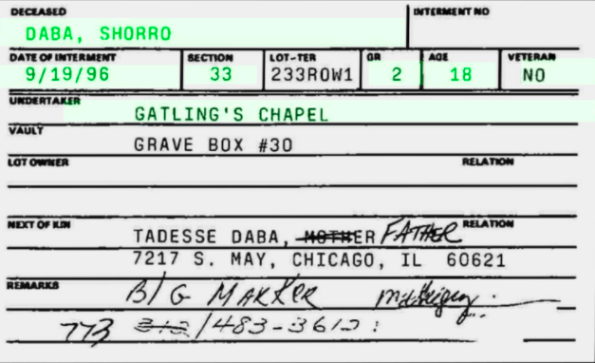

We then cropped these parts of the images as below-

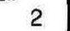

The next step was to run a loop to pass these cropped images into the cloud vision which will read the data and then append it to a list. The following code demonstrates the entore process-

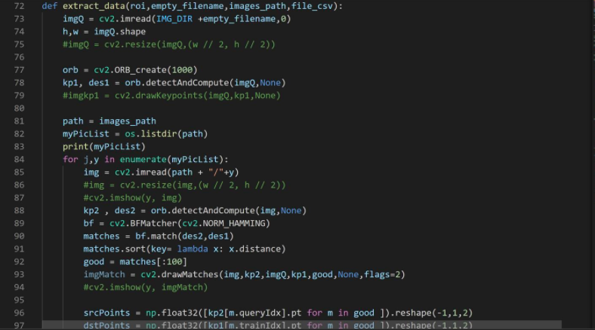

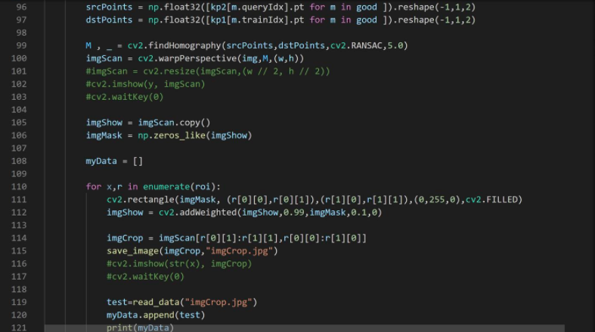

The read_data is the function we created to read the data using cloud vision-

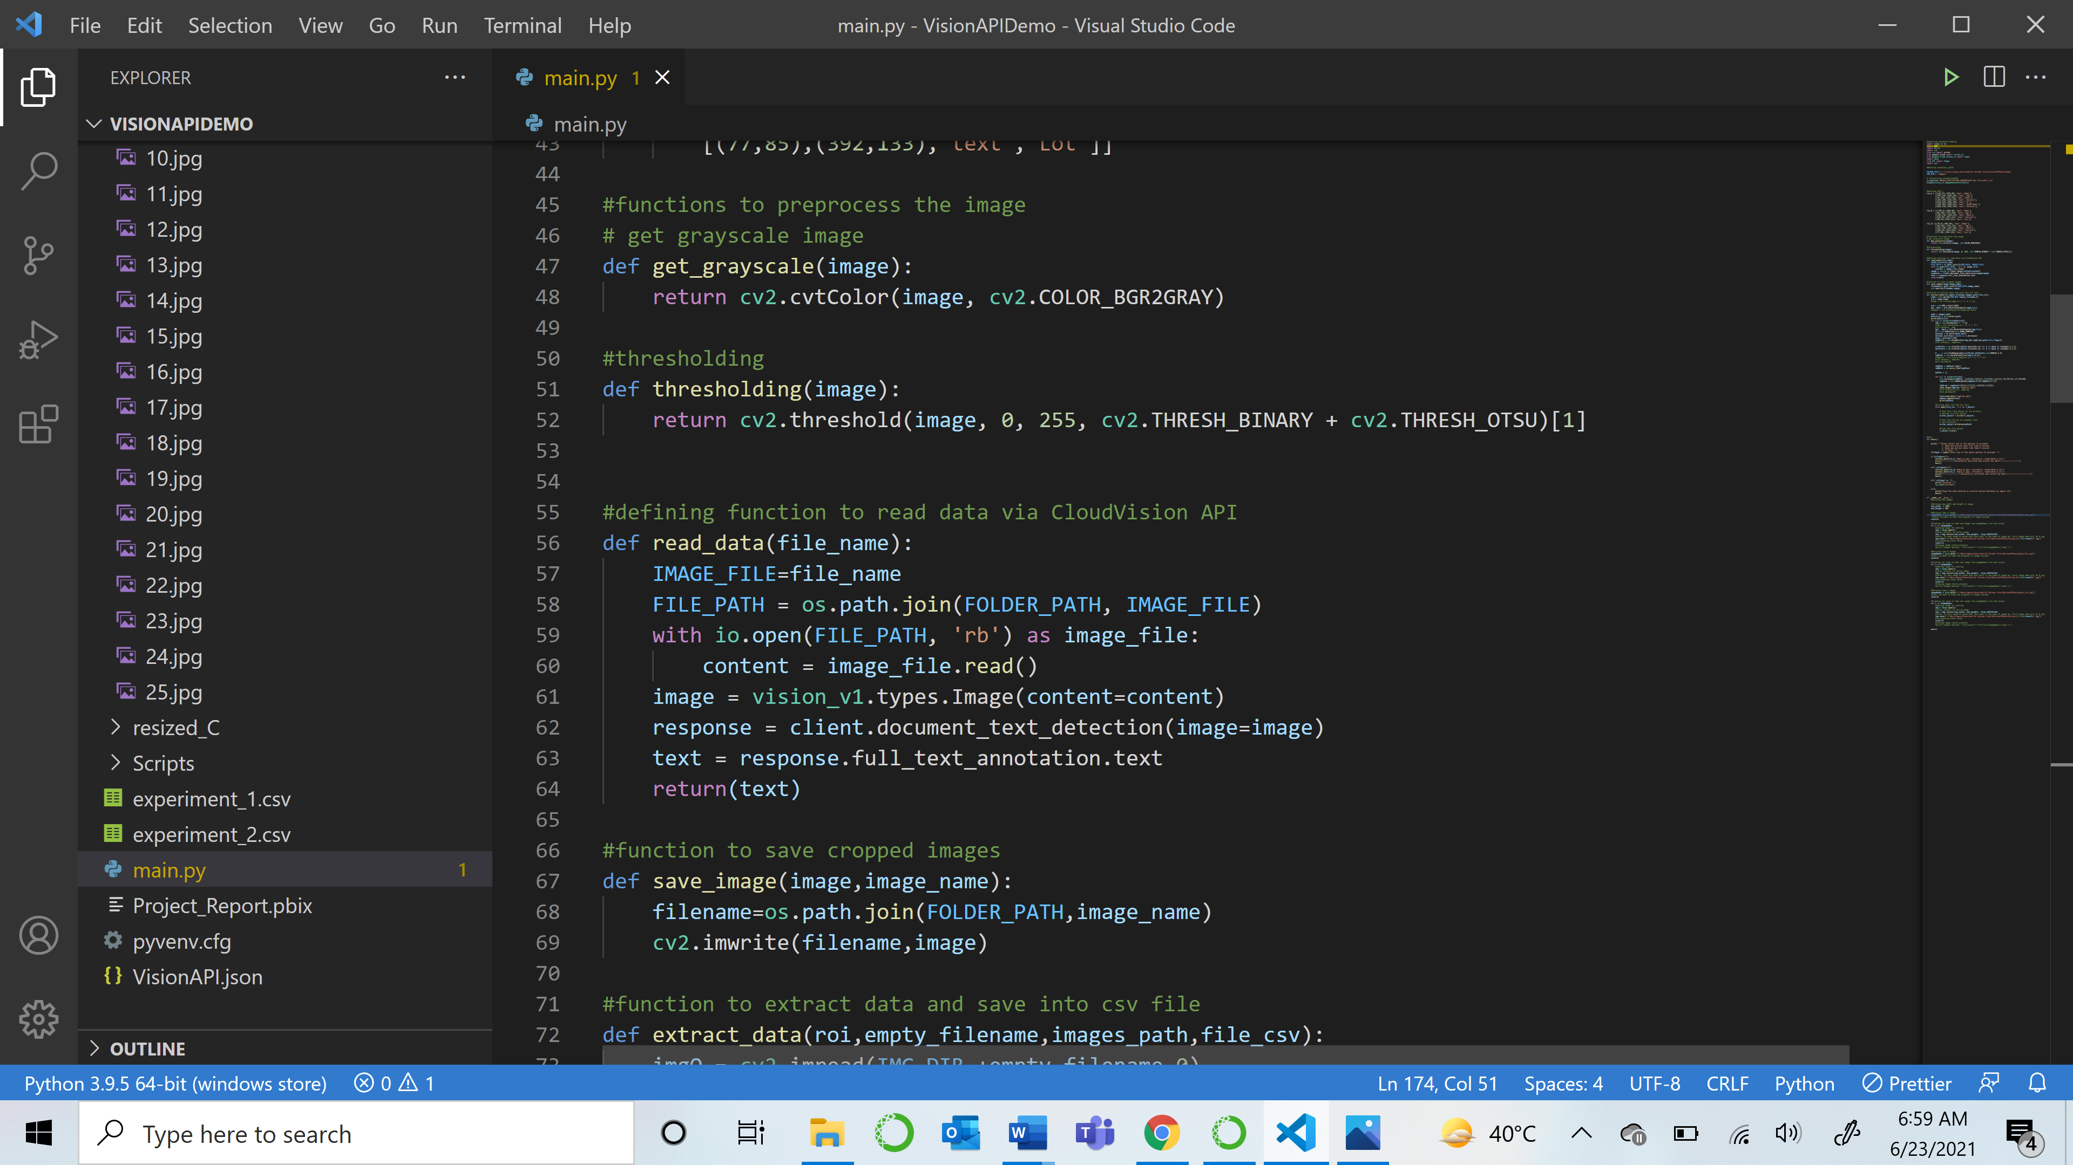

1. Pushing data into the database

After each image was read, the data was pushed into a CSV file.

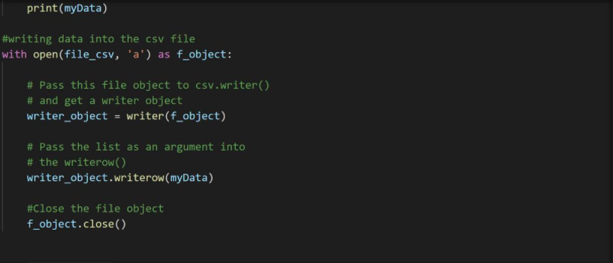

This is how the extracted unclean data looks like-

Type A

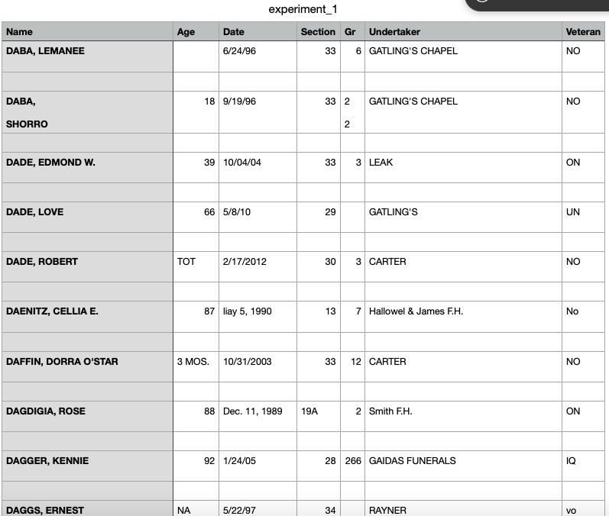

Type B

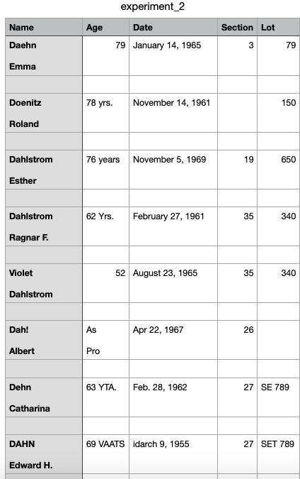

1. Cleaning the data:

Although Cloud Vision displayed a high accuracy in reading the data, there was some cleaning that was required before we could proceed to create our dashboard and get the required insights. This is how the data looks like after cleaning-

Type A

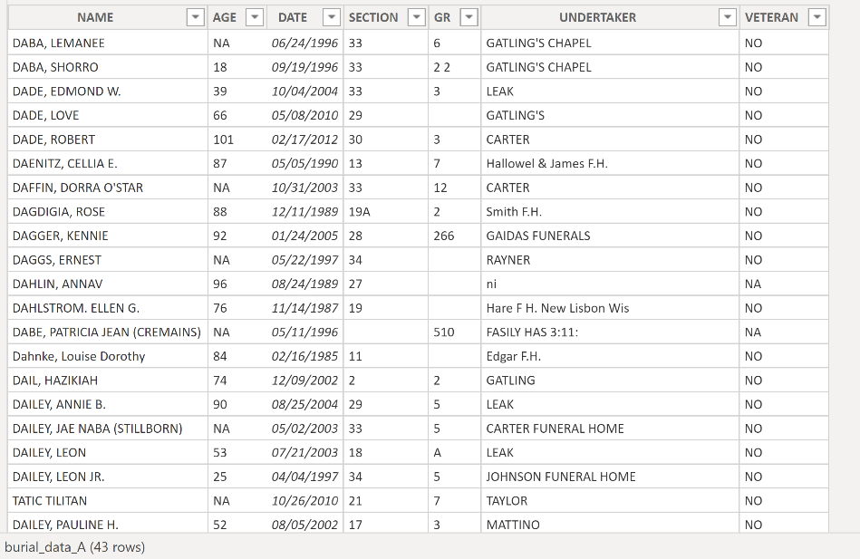

Type B

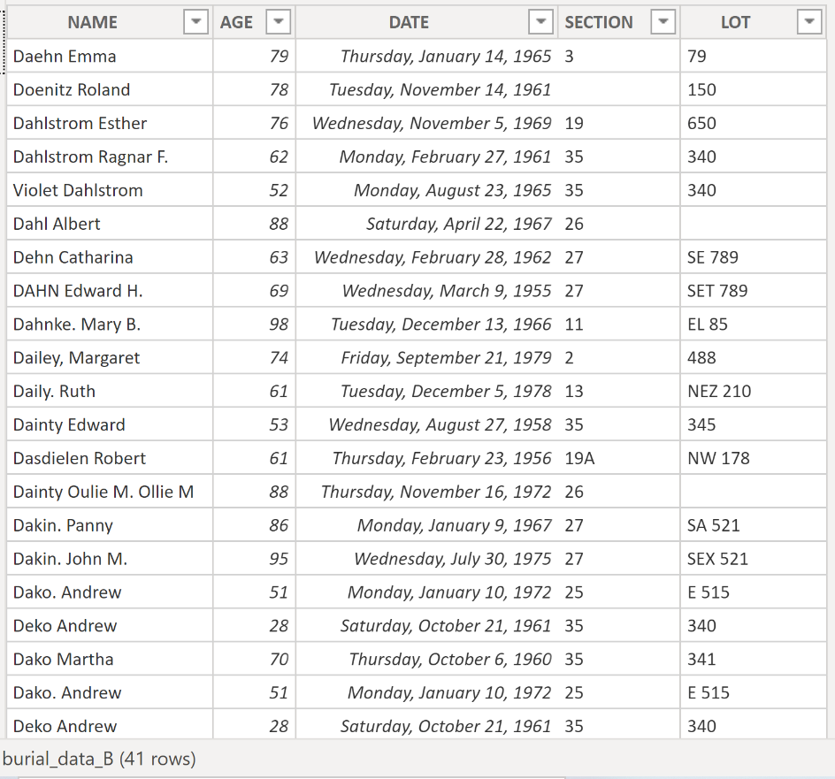

**VISUALIZATION TOOL USED**

We used **Power BI** to load the data from CSV files and create the report and a dashboard.Power BI is a Business Intelligence and Data Visualization tool for converting data from various data sources into interactive dashboards and analysis reports. Power BI offers cloud-based services for interactive visualizations with a simple interface for end users to create their own reports and dashboards.

Report:

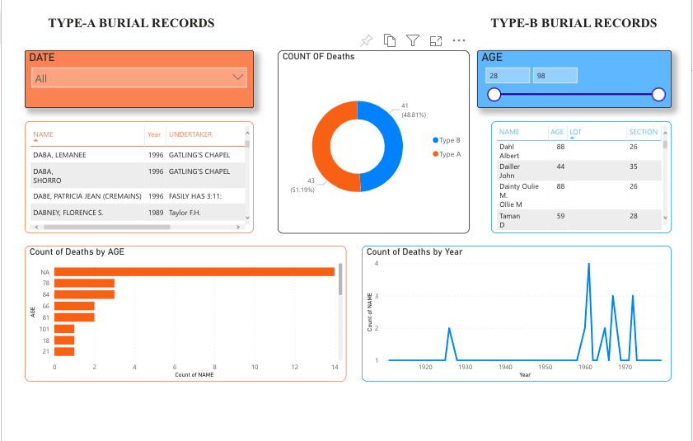

Dashboard:

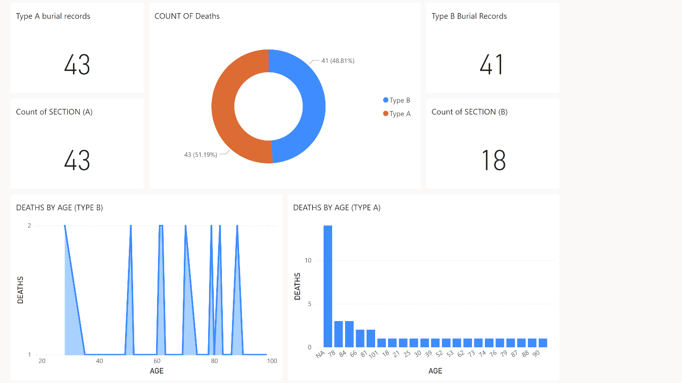

**CHALLENGES FACED**

We faced a lot of challenges especially in the initial stages of the project. We initially used tesseract to read the data but it did not give us high accuracy. Cloud Vision on the other hand displayed excellent results. The challenge was that once an image is fed to the API, it reads all the contents and returns the extracted data as a string. It was very difficult to come up with a method which would extract data from certain parts of the image instead of the image as a whole. We then tried working with a combination of tesseract and Cloud Vision in which Tesseract would detect the words in the image and then those words would be read by Cloud Vision. We tried defining co-ordinates in order to crop the desired parts of the image. This worked well with input of one image. But the challenge was to make the project run for multiple images. This approach was unsuccessful as different images had text placed at slightly different places which made generalizing coordinates impossible.

We then finally came up with a solution which would work on any amount of input images. Detecting and matching keypoints worked really well in locating our desired data and defining the region of interest helped us extract the exact information we were looking for in a proper format.

**CONCLUSION**

The tools used in this project have determined the answers that we were looking for. In the process we worked with Python language in IDE:VS Code combined with Cloud Vision API and OpenCV which were able to extract the images from the forms provided to us. These images were then saved into CSV files used for further analysis.

Per the report we were able to identify that Type A has higher percentage of deathrate after 78 years of age than Type B. The dashboard gave us insights about the accuracy of the records read. Cloud Vision was able to accurately read the ‘**Section’** of all type A records while it accurately read only 18 rows of ‘**Section’** in Type-B. This difference can be attributed to missing information, incorrect placement of data, blurred or unreadable data in Type B records.

Type A which has 43 records collected and Type B which have 41 records collected display big difference in death rate. Type A has higher percentage of deathrate within the age of 75+ than Type B. The records are 14:1 which is a very drastic change. The extraction of the text and visualization method that were used gave a high percentage of accuracy within the analysis that were run in the process.

**REFERENCES**

A. (2015, August 21). *Why Cemeteries Need Management Software*. Cemetery Software - Management, Mapping, Sales. <https://cemsites.com/2015/08/why-cemeteries-need-management-software/>

Schmidt, M. L., Yuan, F., & Jang, W. (2020). Cemetery Mapping and Digital Data Analysis: A Case Study in Minnesota, USA. *Journal of Geography and Geology*, *12*(2), 40. <https://doi.org/10.5539/jgg.v12n2p40>

Solutions, M. (2018, June 16). *Advantages and Disadvantages of Python Programming Language*. Medium. <https://medium.com/@mindfiresolutions.usa/advantages-and-disadvantages-of-python-programming-language-fd0b394f2121>

Mhproductionhouse. (2020, September 11). *OCR OpenCV in FORMS and RECEIPTS | Text Detection 2020 p.1/2*. YouTube. <https://www.youtube.com/watch?v=W9oRTI6mLnU>.

Mhproductionhouse. (2020, September 12). *OCR OpenCV in FORMS and RECEIPTS | Text Detection 2020 p.2/2*. YouTube. <https://www.youtube.com/watch?v=cUOcY9ZpKxw>.

jiejenn. (2019, July 15). *Google Vision API in Python (Part 2): Configuration and Setup*. YouTube. <https://www.youtube.com/watch?v=wfyDiLMGqDM>.